***Software Requirement Specification***

***For***

***Property Management***

***Version 1.0***

# 

# 

Table of Contents

**1. Introduction** 3

**1.1 Purpose** 3

**1.2 Scope** 3

**1.3 Overview** 4

**2.User Description** 5

**2.1 User profile: 1** 5

**2.2 User profile: 2** 6

3. **Specific Requirements** 8

**3.1 List of Functional requirement** 8

**3.1.1 Functional Requirement : Unregistered User** 8

**3.1.1 Functional requirement: Customer Registered User** 9

**3.1.2 Functional requirement: Admin** 13

**3.2 List of Non-Functional requirement** 15

**3.2.1 Error handling** 15

**3.2.2 Performance Requirements** 16

**3.2.3 Safety Requirements** 16

**3.2.4 Security Requirements** 16

**4. Diagrams** 17

**4.1 Use case diagram** 17

**4.2 Activity Diagram** 18

**4.3 Class Diagram** 19

**4.4 Database Diagram** 19

**5. Conclusion** 20

# **1. Introduction**

## **1.1 Purpose**

The purpose of this document is to specify detailed requirements for property management. This is the first version of SRS v1.0 and has not been revised yet. This document gives an overall description of the property management and also describes its functionalities, constraints, assumptions that are necessary for the property portal to have.

## **1.2 Scope**

* PM product is basically a web based which will allow the tenant to choose their best rent.
* This project is developed as a course project of “SWE332: Software Engineering Project-II(Web Programming)”.
* Homeowners can get their best renter to rent their house/home.
* From this web project or system Renter and Homeowner both are get all opportunities.

## **1.3 Overview**

* Chapter 2 describes both primary and secondary user profile
* Chapter 3 shows the list of functional and non-functional requirements including mind-map and requirement prioritization.
* In chapter 4, Given all diagrams.
* Chapter 5 given the conclusion of this project.

# 

# 

# 

# 

# 

# **2.User Description**

## **2.1 User profile: 1**

|  |  |
| --- | --- |
| **User case Unregistered User** | **Characteristic** |
| **User type** | Primary |
| **Age range** | N/A |
| **Number of user** | Unlimited |
| **Education** | Yes |
| **Language skills** | Bengali & English |
| **Computer experience** | Basic |
| **Training** | N/A |
| **Goal** | Unregistered people can just see all the rent and buy post. |

## 

## 

## **2.2 User profile: 2**

## 

|  |  |
| --- | --- |
| **User case Registered Users** | **Characteristic** |
| **User type** | Primary |
| **Age range** | N/A |
| **Number of user** | Not set |
| **Education** | N/A |
| **Language skills** | Bangla & English |
| **Computer experience** | Basic |
| **Training** | N/A |
| **Goal** | Registered people can create a post for rent or by their home or flat. Also they see all the rent and buy posts. |

## 

**2.3 User profile: 3**

|  |  |
| --- | --- |
| **User case Admin** | **Characteristic** |
| **User type** | Secondary |
| **Age range** | N/A |
| **Number of user** | Only one person |
| **Education** | Yes |
| **Language skills** | Bangla & English |
| **Computer experience** | Basic |
| **Training** | N/A |
| **Goal** | An Admin has access to everythings. |

# 3. **Specific Requirements**

## **3.1 List of Functional requirement**

### **3.1.1 Functional Requirement : Unregistered User**

|  |  |
| --- | --- |
|  |  |
| **Requirement ID** | FR.UU.1 |
| **Requirement Name** | View Rent |
| **Description** | Unregistered User can view rent |

|  |  |
| --- | --- |
|  |  |
| **Requirement ID** | **FR.UU.2** |
| **Requirement Name** | **Buy Rent** |
| **Description** | **Unregistered User can Buy rent** |

### **3.1.1 Functional requirement: Customer Registered User**

|  |  |
| --- | --- |
|  |  |
| **Requirement ID** | FR.RU.1 |
| **Requirement Name** | Login |
| **Description** | Registered user can log in using username and Password |

|  |  |
| --- | --- |
|  |  |
| **Requirement ID** | FR.RU.2 |
| **Requirement Name** | Registration |
| **Description** | For login User must be registered |

|  |  |
| --- | --- |
|  |  |
| **Requirement ID** | FR.RU.3 |
| **Requirement Name** | View Post |
| **Description** | Registered User can view Post |

|  |  |
| --- | --- |
|  |  |
| **Requirement ID** | FR.RU.4 |
| **Requirement Name** | Create post |
| **Description** | Registered User can Create post |

|  |  |
| --- | --- |
|  |  |
| **Requirement ID** | FR.RU.5 |
| **Requirement Name** | Edit post |
| **Description** | Registered User can Edit post |

|  |  |
| --- | --- |
|  |  |
| **Requirement ID** | FR.RU.6 |
| **Requirement Name** | Update post |
| **Description** | Registered User can Update post |

|  |  |
| --- | --- |
|  |  |
| **Requirement ID** | FR.RU.7 |
| **Requirement Name** | Review |
| **Description** | Registered User can give review to admin |

|  |  |
| --- | --- |
|  |  |
| **Requirement ID** | FR.RU.8 |
| **Requirement Name** | Logout |
| **Description** | Registered User can Logout |

### **3.1.2 Functional requirement: Admin**

|  |  |
| --- | --- |
|  |  |
| **Requirement ID** | FR.A.1 |
| **Requirement Name** | Login |
| **Description** | Admin can log in using user name and Password |

|  |  |
| --- | --- |
|  |  |
| **Requirement ID** | FR.A.2 |
| **Requirement Name** | Delete Post |
| **Description** | Admin can Delete Post |

|  |  |
| --- | --- |
|  |  |
| **Requirement ID** | FR.A.3 |
| **Requirement Name** | Approve post |
| **Description** | Admin should Approve post to display |

|  |  |
| --- | --- |
|  |  |
| **Requirement ID** | FR.A.4 |
| **Requirement Name** | View post |
| **Description** | Admin can view post |

|  |  |
| --- | --- |
|  |  |
| **Requirement ID** | FR.A.5 |
| **Requirement Name** | View Pending post |
| **Description** | Admin can view Pending post |

|  |  |
| --- | --- |
|  |  |
| **Requirement ID** | FR.A.6 |
| **Requirement Name** | Logout |
| **Description** | Admin can Logout |

## 

## **3.2 List of Non-Functional requirement**

### **3.2.1 Error handling**

· WLMS Product shall handle expected and unexpected errors in ways that prevent loss in information and long downtime period.

### **3.2.2 Performance Requirements**

· The system will accommodate a high number of Posts and users without any fault.

· Responses to view information will take no longer than 5 seconds to appear on the screen.

### **3.2.3 Safety Requirements**

· System use will not cause any harm to human users.

### **3.2.4 Security Requirements**

· System will use secured database

· Registered users can just read information but they cannot edit or modify anything except their personal and posted information.

· System will have different types of users and every user has access constraints.

# **4. Diagrams**

## **4.1 Use case diagram**

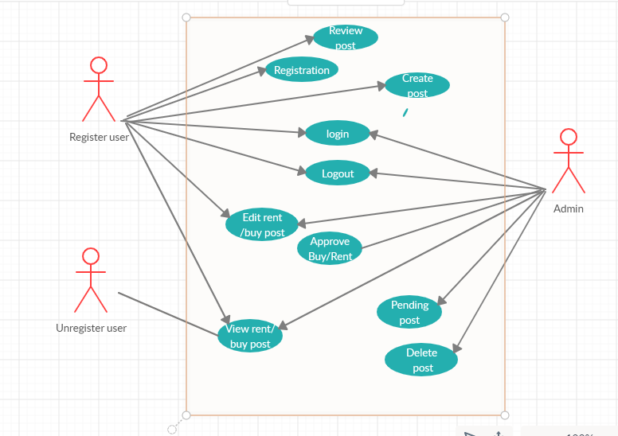

## **4.2 Activity Diagram**

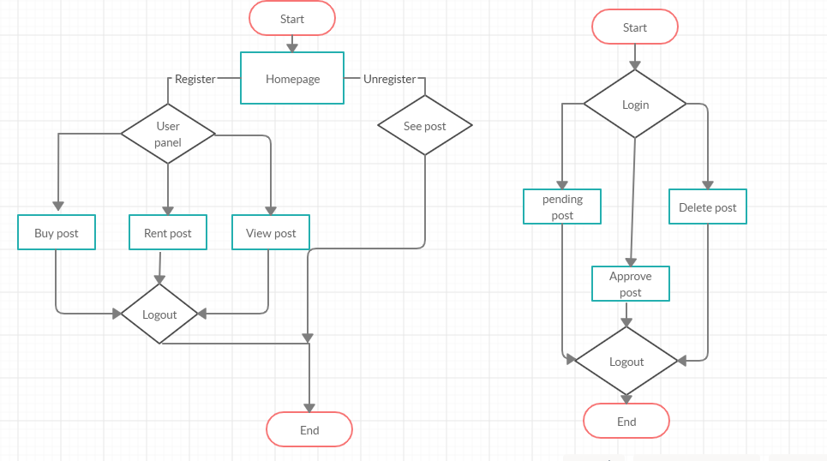

## **4.3 Class Diagram**

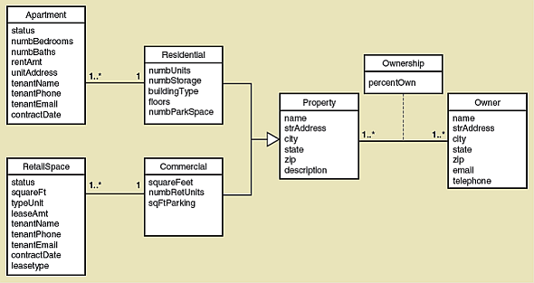

## **4.4 Database Diagram**

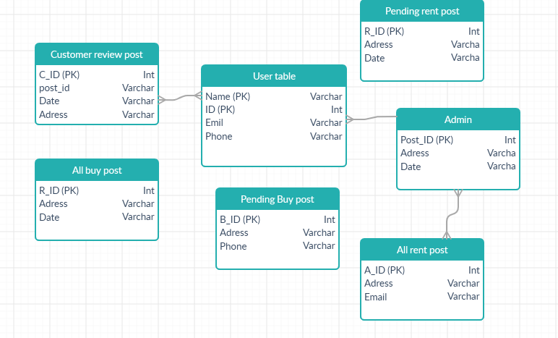

# **5. Conclusion**

We are working on an Online Property Management Website. Here, we complete our SRS. Made our template properly, also trying to complete our admin part before the MID term submissions. After the MID exam we will be working on the User part and will finish our whole project.

THE END

---------o---------